Internship Report

(INTERNSHIP-PCA20P01L, MCA-III Semester,2nd Year)

*on*

**Classmonk.com**

*[*

*Submitted*

*by*

Jatin Sharma

(RA2132241030008)



**DEPARTMENT OF COMPUTER APPLICATIONS**

**SRMInstitute of Science & Technology**

**NCR Campus, Modinagar**

**Delhi-MeerutRoad, SikariKalan, Modinagar–201204, GHAZIABAD (U.P.)**

**ACKNOWLEDGEMENT**

First I would like to thank Mr. Deepak Yadav, for giving me the opportunity to do an internship within the organization.

I am extremely great full to my department staff members and friends who helped me in successful completion of this internship.

Jatin Sharma

(RA2132241030008)

**DECLARATION**

My name is **Jatin Sharma** student of MCA, Second year, 3nd Semester for the award of MCA degree course in the Department of Computer Applications in **Internship** during the Academic year-2022-23 .

**Name :** Jatin Sharma

**Registration No :** RA2132241030008

**Date :** 1-11-2022

**ABSTRACT**

The internship report highlights the major works carried out by the author in terms of academic and non-academic perspectives. The scope of this document is to identify and describe the analysis carried out, projects completed, experience gained and focuses on the achievements as an intern.

The quest to make life easier and processing faster has led to computerization of various processes. Computer technology has transformed so many sectors especially the Educational sector in no small measure.

In an effort to foster technology driven education, www.classmonk.com has been develop to make a common platform for instructor and students for utilizing their leisure time to share knowledge and increase knowledge. The author was sent to Developers Ltd to complete his internship. The author found him rather lucky by getting the chance to work in such an environment that Developers provided and got introduced to some of the new terms, new technologies and new Languages.

The projects that the author worked in certainly helped him by increasing his practical knowledge depth. The research and development projects were particularly helpful in widening his views regarding different web application development frameworks.

**Certificate Received From Company**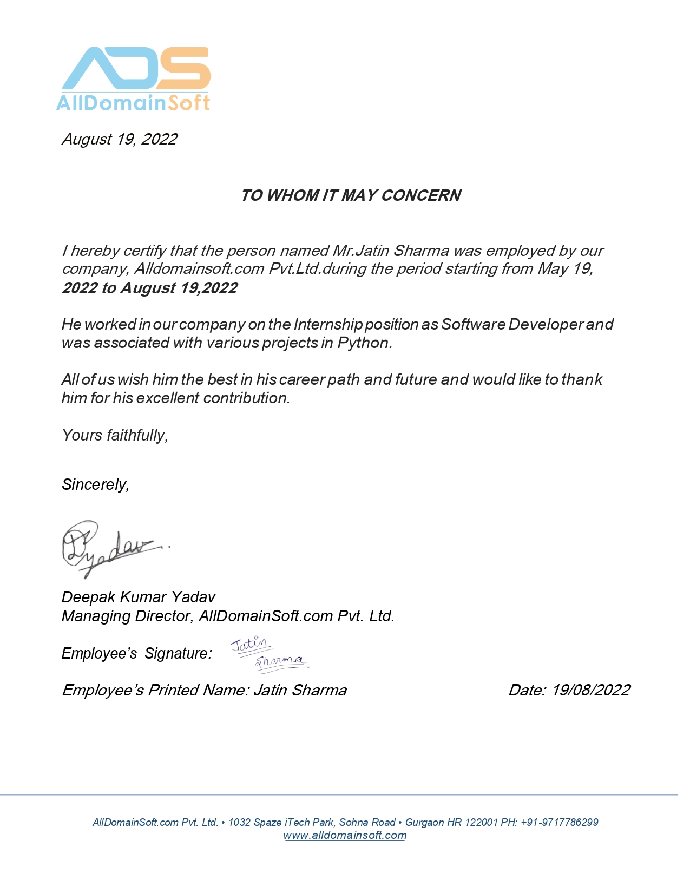

**TABLE OF CONTENTS**

|  |  |  |
| --- | --- | --- |
| **S.No** | **Contents** | **Page No** |
| 1. | About Company |  |
| 2. | Domain |  |
| 3. | Task Assigned |  |
| 4. | Tools & Technologies Used |  |
| 5. | Result (in the form of screenshots) |  |
| 6. | References |  |

**Chapter no. 1**

**About Company**

Alldomainsoft.com Private Limited is a Private incorporated on 04 September 2012. It is classified as Non-govt Company and is registered at Registrar of Companies, Delhi. Its authorized share capital is Rs. 100,000 and its paid up capital is Rs. 100,000. It is involved in Software publishing, consultancy and supply [Software publishing includes production, supply and documentation of ready-made (non-customized) software, operating systems software, business & other applications software, computer games software for all platforms. Consultancy includes providing the best solution in the form of custom software after analyzing the user’s needs and problems.

Alldomainsoft.com Private Limited's Annual General Meeting (AGM) was last held on 30 September 2021 and as per records from Ministry of Corporate Affairs (MCA), its balance sheet was last filed on 31 March 2021.

Directors of Alldomainsoft.com Private Limited are Ved Parkash Yadav and Deepak Kumar Yadav.

Alldomainsoft.com Private Limited's Corporate Identification Number is (CIN) U72200HR2012PTC047006 and its registration number is 47006.Its Email address is DKYADAV.ORG@GMAIL.COM and its registered address is 253/1 BHIMGARH KHERI GURGAON HR 122001 IN

**Chapter no. 2**

**Domain**

**Classmonk.com**

Classmonk is an online platform which helps instructor and student to utilizing their leisure time by sharing knowledge and learning new things. The main hierarchy start from city name. Each city is added by admin where they want to give the services.

There are mainly two types of users first one is normal user / Student who do simple signup using email/password or social signup and second one is instructor account. And instructor account is also categorized in normal instructor and business account. Business account is for enterprise level who want to do run institute.

Student or any user can visit any city and can find the listed classes. There is flexible search and filter options for better experience in finding class. With the integration of google map on it is much easier to find the location and the distance is auto calculated by the Classmonk. Visitor can enter their home location and the distance is calculated to the instructor location

Wish list features helps visitor to save the class as reminder for latter. Student can send email to their friends to participate on the class. Similar classes are suggested according to the user past surfing behavior. This feature helps to increase user experience and save time.

Dashboard are designed for both student and instructor. Dashboard contain the class list payment history messages and inquiries and many more.

Instructor can create two types of classes. One is package based e.g. driving and second is regular recurring classes e.g. yoga. Instructor have features to set pricing seat time duration etc.

**Chapter no. 3**

**Task Assigned**

During the internship period knowledge of various platforms and programming languages are gained. The target was to deliver a fully-fledged web based system by using different tools and frameworks such as PHP (Laravel) and JS (Angular).

Hence, to meet that objective, this internship required the extensive preliminary studies about the core PHP before actually analyzing the actual requirement of the system. The study was required not only to understand the subject under study but also to realize the solutions to the existing problems and implementing the findings from the study was another bigger challenge. Besides study of, Core PHP other major activities carried out during internship was extensive study of current online platform, presentations of study analysis and practical implementations, and most importantly the team discussions to analyze the customer change request. The regular meetings with the Supervisor and discussion with mentors helped me to wide my horizon of knowledge of the existing system and problem background. Software development is one of the major services of the Developers Company. Developers provides a flexible and scalable solutions of software (web based or desktop based) to meet our needs for small or large firm.

Software development is the collective processes involved in creating software programs, embodying all the stages throughout the systems development life cycle (SDLC). During my internship, Author worked on Classmonk project which was based on PHP (Laravel) and JavaScript (Angular) frame work.

**Chapter no. 4**

**Tools and Technologies Used**

When author has been told to work on Classmonk, author asked Deepak sir which technologies author need to learn to work this project. He gave me a list of technologies and author learned them.

* SQL Query
* Angular ( Front end JavaScript framework)
* Web Socket
* PHP (Laravel framework)

**Chapter no. 5**

**Results**

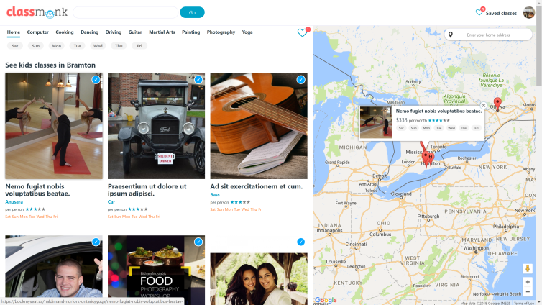

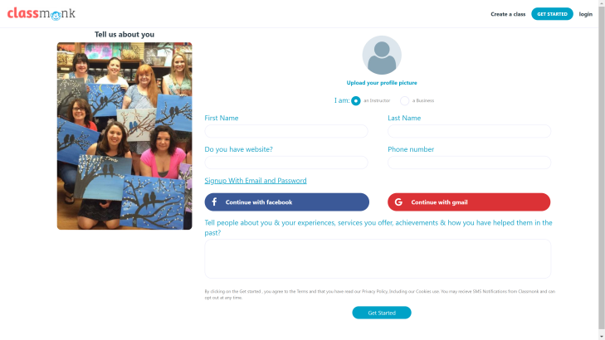

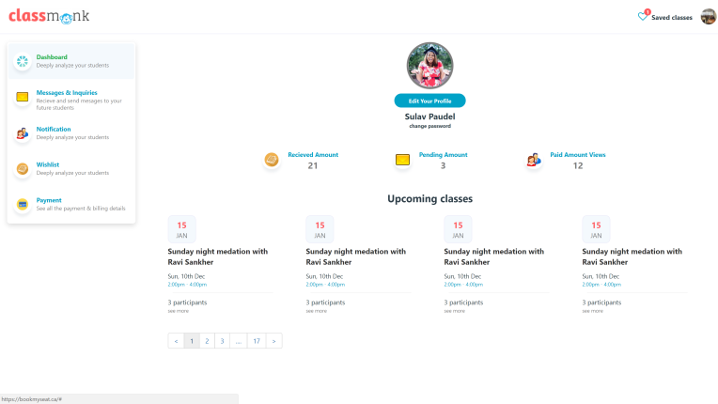

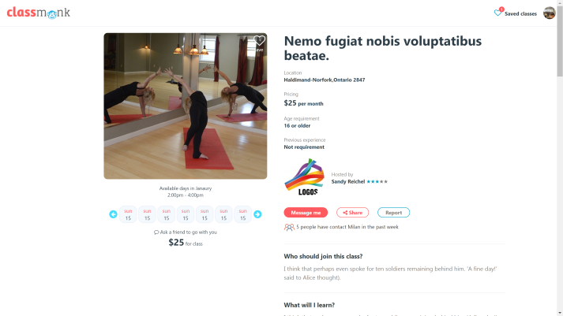

**Chapter no. 6**

**References**

1. SearchSoftwareQuality. (2018). What is Web application (Web app)? - Definition from WhatIs.com. [online] Available at: http://searchsoftwarequality.techtarget.com/definition/Web-application-Web-app [Accessed 8 Mar. 2018].
2. Google Developers. (2018). Progressive Web Apps | Web | Google Developers. [online] Available at: https://developers.google.com/web/progressive-web-apps/ [Accessed 8 Mar. 2018].
3. Forbes.com. (2018). Forbes Welcome. [online] Available at: https://www.forbes.com/sites/forbestechcouncil/2017/04/07/how-to-choose-a-front-end-framework/ [Accessed 8 Mar. 2018].
4. Yuan, C., Li, D. and Li, Y. (2014). Review on Real-Time Communications Technology in Web Application. Advanced Materials Research, 1044-1045, pp.1309-1314.
5. Barabino, G., Concas, G., Corona, E., Grechi, D., Marchesi, M. and Tigano, D. (2015). Web framework points: an effort estimation methodology for Web application development using a content management framework. Journal of Software: Evolution and Process, 27(9), pp.603-624.
6. Bog, A. (2014). Benchmarking transaction and analytical processing systems. Berlin: Springer.
7. Enriquez, R. (2014). RESTful Java Web Services Security. Birmingham: Packt Publishing.